AI-Powered Multi-Modal Healthcare Diagnostic System

Team Members
- Team Member 1: محمد رمضان محجوب علي
- Team Member 2: احمد ايمن احمد علي
- Team Member 3: احمد سالم حسين سالم
- Team Member 4: بافلي هشام ابراهيم حليم
- Team Member 5: جمال علي بلال سالم
- Team Member 6:عبدالهادي ايمن جوده السيد
- Team Member 7:كيرلس حنين صداق يوسف

Project Title
AI-Powered Multi-Modal Healthcare Diagnostic System

Project Domain
Artificial Intelligence, Machine Learning, Deep Learning, Healthcare Technology, Medical Image Analysis, and Retrieval-Augmented Generation.

Table of Contents
- Executive Summary
- Project Introduction
- Problem Statement
- Project Objectives
- Project Scope
- System Overview
- Technologies Used
- System Architecture
- Machine Learning Module
- Deep Learning Module
- Retrieval-Augmented Generation Module
- Gemini AI Integration
- User Interface Design
- Data Flow and Workflow
- Implementation Details
- Project Features
- Expected Outputs
- Evaluation and Testing
- Advantages of the System
- Limitations
- Future Enhancements
- Ethical and Medical Disclaimer
- Conclusion

1. Executive Summary
The Smart Healthcare Diagnostic Hub is an advanced Artificial Intelligence-based healthcare platform designed to support medical analysis, disease prediction, and intelligent healthcare reporting. The project combines multiple AI technologies, including Machine Learning, Deep Learning, Retrieval-Augmented Generation, and Large Language Models, into one integrated system.
The system allows users to enter patient medical information, upload chest X-ray images, and receive an AI-generated diagnostic report. It uses a Machine Learning model to predict diabetes risk, a Deep Learning model to analyze chest X-ray images for pneumonia detection, and a Retrieval-Augmented Generation pipeline to retrieve relevant medical knowledge from stored documents. Finally, Gemini AI is used to generate a clear, structured, and human-readable medical report.
This project demonstrates how modern AI techniques can be combined to create intelligent healthcare applications that are more explainable, interactive, and useful than traditional single-model systems.

2. Project Introduction
Healthcare is one of the most important fields where Artificial Intelligence can provide real value. Many medical decisions depend on analyzing patient information, identifying disease patterns, reviewing medical images, and understanding large amounts of medical knowledge.
Traditional healthcare systems usually require doctors or specialists to manually analyze data and medical images. Although human expertise is essential, AI systems can help by providing fast predictions, decision support, and summarized medical insights.
The Smart Healthcare Diagnostic Hub was developed as a complete AI-based diagnostic assistant. It does not replace doctors, but it helps users understand possible health risks by combining different types of analysis in one platform.
The project focuses on two main diagnostic tasks:
- Diabetes risk prediction using structured patient health data.
- Pneumonia detection using chest X-ray image analysis.
In addition, the system uses a RAG pipeline to retrieve medical information from documents and Gemini AI to generate a professional medical report.

3. Problem Statement
Medical diagnosis often requires analyzing different types of data, such as numerical health indicators, patient lifestyle information, symptoms, and medical images. Handling all these data sources manually can be time-consuming and complex.
There are several challenges in traditional medical analysis:
- Patient data may be difficult to interpret without medical knowledge.
- Medical images require trained specialists.
- AI predictions alone may lack explanation.
- General AI models may generate answers without reliable medical context.
- Users need a simple interface to interact with complex AI systems.
The problem addressed by this project is the need for an intelligent healthcare assistant that can combine prediction, medical image analysis, document retrieval, and AI-generated explanation in a single workflow.

4. Project Objectives
The main objective of this project is to build a smart healthcare diagnostic system that supports medical decision-making using AI.
Specific objectives include:
- Build a Machine Learning model for diabetes risk prediction.
- Build or integrate a Deep Learning model for pneumonia detection from chest X-ray images.
- Create a RAG pipeline that retrieves relevant medical information from stored documents.
- Use Gemini AI to generate detailed medical reports.
- Develop an interactive user interface using Gradio.
- Combine structured data, image data, and retrieved text into one diagnostic workflow.
- Provide users with clear and understandable outputs.

5. Project Scope
The project covers the design and implementation of a healthcare diagnostic assistant using Artificial Intelligence. It includes data preprocessing, model loading, prediction logic, document retrieval, AI-generated reporting, and user interface development.
The project scope includes:
- Structured medical data processing.
- Diabetes prediction using Machine Learning.
- Chest X-ray image classification using Deep Learning.
- Medical document ingestion and chunking.
- Vector embedding generation.
- Hybrid search and retrieval.
- Gemini AI response generation.
- Gradio-based web interface.
The project does not provide official medical diagnosis and should only be used for educational and research purposes.

6. System Overview
The Smart Healthcare Diagnostic Hub consists of several connected components. Each component performs a specific role in the diagnostic pipeline.
The system receives user inputs such as patient medical indicators, symptoms, and chest X-ray images. These inputs are processed by different AI modules. The Machine Learning model analyzes patient health data, while the Deep Learning model analyzes the uploaded X-ray image.
At the same time, the RAG module searches through medical documents to retrieve relevant information. The retrieved information, together with the model predictions, is passed to Gemini AI. Gemini AI then generates a final medical report.
The final output is shown to the user through an interactive Gradio interface.

7. Technologies Used
The project uses a combination of modern AI and software development technologies.

Programming Language
- Python: Main programming language used for data processing, model integration, backend logic, and application development.

Machine Learning
- Scikit-learn: Used for training and running classical Machine Learning models.
- Pandas: Used for data manipulation and structured data processing.
- NumPy: Used for numerical operations and array processing.

Deep Learning
- TensorFlow / Keras: Used for loading and running the Deep Learning model for X-ray image classification.
- DenseNet-based Architecture: Used for medical image feature extraction and pneumonia classification.

Retrieval-Augmented Generation
- Sentence Transformers: Used to convert medical text into embeddings.
- FAISS / Vector Database: Used for fast similarity search over embedded documents.
- BM25 / Hybrid Search: Used to improve retrieval accuracy by combining keyword-based and semantic search.

Large Language Model
- Google Gemini AI: Used to generate final medical explanations and diagnostic reports.

User Interface
- Gradio: Used to build an interactive web interface for user input and output display.

8. System Architecture
The system follows a modular architecture. Each module is responsible for a specific task, which makes the project easier to understand, maintain, and improve.
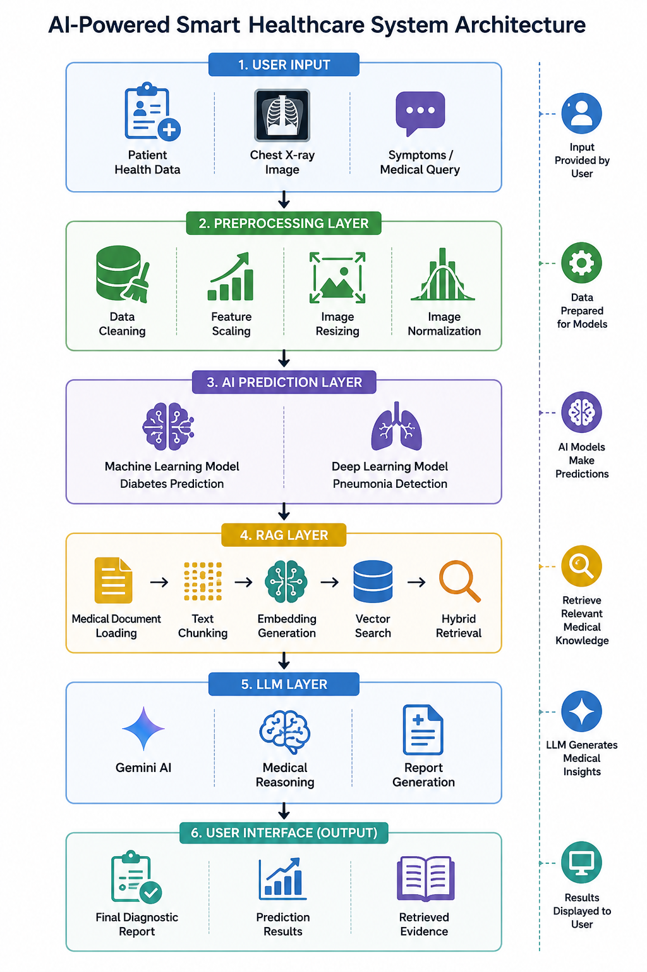

9. Machine Learning Module
The Machine Learning module is responsible for diabetes risk prediction. It analyzes structured patient data and predicts whether the patient may be at risk of diabetes.

Input Features
The model may use features such as:
- Blood pressure
- Cholesterol level
- Body Mass Index
- Smoking status
- Physical activity
- Stroke history
- General health condition
- Age category
- Lifestyle indicators

Processing Steps
The Machine Learning workflow included the following preprocessing and modeling steps:
- Load the dataset using Pandas.
- Handle missing values by removing rows containing null values (dropna).
- Analyze the target variable distribution to detect class imbalance.
- Separate input features and target labels into X and y.
- Apply feature scaling using StandardScaler to normalize the feature values.
- Split the dataset into training and testing sets using train_test_split.
- Handle class imbalance using:
  - SMOTE (Oversampling) to generate synthetic minority samples.
  - NearMiss (Undersampling) to balance the dataset.
- Perform feature selection by removing low-significance features such as:
Fruits, Veggies, Sex, CholCheck, and AnyHealthcare.
- Apply feature engineering by creating new interaction features, including:
  - GenHlth_BMI
  - Age_HighBP
  - PhysHlth_NoActivity
- Re-scale the engineered features after feature creation.
- Train Machine Learning and Deep Learning models on the processed dataset.
- Pass user input to the trained model for prediction.
- Generate the final prediction result.

Output
The output of the Machine Learning module is a diabetes risk prediction. The result may be shown as:
- Diabetes Risk
- No Diabetes Risk
This prediction is later included in the final AI-generated report.

10. Deep Learning Module
The Deep Learning module is responsible for analyzing chest X-ray images. Its main purpose is to detect whether the uploaded image indicates pneumonia or a normal case.

Image Input
The user uploads a chest X-ray image through the interface. The image is then processed before being passed to the model.

Image Preprocessing
The preprocessing stage may include:
- Resizing the image to the required model input size.
- Converting the image into an array.
- Normalizing pixel values.
- Expanding dimensions to match model input shape.
Example preprocessing logic:
image = image.resize((224, 224))
image_array = np.array(image) / 255.0
image_array = np.expand_dims(image_array, axis=0)

Model Architecture
The project uses a CNN-based Deep Learning approach. A DenseNet121-based architecture may be used because DenseNet models are powerful for image classification tasks and are commonly used in medical image analysis.

Output
The Deep Learning model classifies the X-ray image into one of the following categories:
- Normal
- Pneumonia
This result is passed to the report generation module.

11. Retrieval-Augmented Generation Module
Retrieval-Augmented Generation, also known as RAG, is one of the most important parts of the project. It helps the system generate more reliable and context-aware responses.
Instead of asking Gemini AI to answer directly without context, the system first retrieves relevant medical information from a knowledge base. This retrieved information is then used as supporting context for the final response.

Why RAG is Important
RAG improves the quality of AI responses because it:
- Reduces unsupported answers.
- Provides medical context from documents.
- Helps the LLM generate more accurate explanations.
- Makes the output more evidence-based.
- Allows the system to use project-specific medical resources.

RAG Workflow
The RAG workflow includes:
- Load medical documents.
- Extract text from documents.
- Split text into smaller chunks.
- Convert chunks into embeddings.
- Store embeddings in a vector database.
- Search for relevant chunks based on user input.
- Send retrieved chunks to Gemini AI.
- Generate the final medical report.

12. Gemini AI Integration
Gemini AI is used as the reasoning and report-generation component of the project. After receiving the ML prediction, DL prediction, user symptoms, and retrieved medical evidence, Gemini AI generates a final report.

Role of Gemini AI
Gemini AI performs the following tasks:
- Explains prediction results.
- Combines structured data and image analysis.
- Uses retrieved medical context.
- Produces a clear diagnostic-style report.
- Makes the output easier for users to understand.

Final Report Content
The generated report may include:
- Summary of patient input.
- Diabetes risk result.
- Chest X-ray result.
- Relevant medical evidence.
- Possible explanation of results.
- Recommended next steps.
- Medical disclaimer.

13. User Interface Design
The project uses Gradio to build an interactive web interface. Gradio is suitable for AI projects because it allows fast development of user-friendly interfaces.

Interface Components
The interface may include:
- Text fields for patient information.
- Numeric inputs for health indicators.
- Dropdowns for lifestyle choices.
- Image upload component for chest X-ray images.
- Submit button to run analysis.
- Output box for the final medical report.
- Additional output section for retrieved RAG evidence.

Benefits of Gradio
- Easy to use.
- Fast development.
- Works well with AI models.
- Can be launched locally or deployed online.
- Supports images, text, numbers, and file inputs.

14. Data Flow and Workflow
The complete project workflow starts when the user enters patient information and uploads an X-ray image.

Step-by-Step Workflow
- The user opens the Gradio interface.
- The user enters patient medical information.
- The user uploads a chest X-ray image.
- The system preprocesses structured health data.
- The ML model predicts diabetes risk.
- The system preprocesses the X-ray image.
- The DL model predicts whether the image is normal or pneumonia.
- The RAG system retrieves relevant medical information.
- Gemini AI receives all results and context.
- Gemini AI generates the final medical report.
- The report is displayed to the user.

15. Implementation Details
The implementation is divided into separate modules to make the system clean and maintainable.

Core Modules
The project may include the following core components:
- chunker.py: Splits medical documents into smaller text chunks.
- embedding.py: Generates embeddings for text chunks.
- hybrid_search.py: Combines semantic and keyword search.
- ingest.py: Loads and processes medical documents.
- llm_service.py: Handles Gemini AI communication.
- rag_engine.py: Controls the RAG pipeline.
- reranker.py: Improves retrieved results ranking.
- retriever.py: Retrieves relevant medical chunks.
- vector_db.py: Manages the vector database.

Application File
The main application file is usually responsible for:
- Loading models.
- Loading environment variables.
- Defining prediction functions.
- Connecting ML, DL, RAG, and LLM modules.
- Creating the Gradio interface.
- Launching the application.

16. Project Features
The Smart Healthcare Diagnostic Hub includes several important features:

Multi-Modal Analysis
The system can process both structured data and medical images.

AI-Generated Medical Reports
The system does not only output predictions. It also generates a full explanation using Gemini AI.

RAG-Based Evidence Retrieval
The system retrieves relevant information from medical documents to support the response.

Interactive Dashboard
The Gradio interface makes the system easy to use.

Modular Design
Each part of the system is separated into modules, making it easier to maintain and upgrade.

Educational Value
The project demonstrates many advanced AI concepts in one practical application.

17. Expected Outputs
The system produces a final report that may contain:
- Patient information summary.
- Diabetes prediction result.
- Pneumonia detection result.
- Medical explanation.
- Retrieved evidence from documents.
- Suggested medical advice.
- Disclaimer that the system is not a replacement for doctors.
Example output structure:
Patient Summary:
The patient entered health indicators related to diabetes risk and uploaded a chest X-ray image.
Diabetes Prediction:
The Machine Learning model indicates possible diabetes risk.
Chest X-ray Analysis:
The Deep Learning model predicts pneumonia.
Medical Explanation:
Based on retrieved medical context, the symptoms and image result may require further medical examination.
Recommendation:
Please consult a qualified healthcare professional for official diagnosis and treatment.

18. Evaluation and Testing
Testing is an important part of the project to ensure that each component works correctly.

Machine Learning Testing
The ML model can be evaluated using:
- Accuracy
- Precision
- Recall
- F1-score
- Confusion matrix

Deep Learning Testing
The DL model can be evaluated using:
- Validation accuracy
- Loss curves
- Precision and recall
- Confusion matrix
- Test image predictions

RAG Testing
The RAG system can be tested by checking:
- Whether relevant documents are retrieved.
- Whether retrieved chunks match the user query.
- Whether Gemini AI uses the retrieved context correctly.

UI Testing
The interface can be tested by checking:
- Input fields.
- Image upload.
- Prediction button.
- Output display.
- Error handling.

19. Advantages of the System
The project has several advantages:
- Combines multiple AI technologies in one system.
- Supports both structured data and image data.
- Generates explanations, not just predictions.
- Uses RAG to improve reliability.
- Provides an interactive web interface.
- Has a modular and scalable structure.
- Can be expanded to support more diseases.

20. Limitations
Although the project is powerful, it has some limitations:
- It depends on the quality of the trained models.
- It depends on the quality of medical documents used in the RAG system.
- It cannot replace professional medical diagnosis.
- It may produce incorrect results if input data is inaccurate.
- It may require more validation before real-world healthcare use.
- Medical AI systems must be carefully tested before deployment.

21. Future Enhancements
The project can be improved in several ways:
- Add more disease prediction models.
- Improve the pneumonia detection model.
- Add explainable AI visualizations such as Grad-CAM.
- Add multilingual support.
- Deploy the system on the cloud.
- Add user authentication.
- Add patient history tracking.
- Integrate with Electronic Health Records.
- Add doctor review functionality.
- Improve RAG evaluation and source citation.

22. Ethical and Medical Disclaimer
This project is designed for educational and research purposes only.
The system should not be used as a replacement for professional medical advice, diagnosis, or treatment. AI-generated results may be helpful for learning and decision support, but final medical decisions must always be made by qualified healthcare professionals.
Users should consult a doctor or licensed medical provider before making any health-related decisions based on the system output.

23. Conclusion
The Smart Healthcare Diagnostic Hub is a complete AI-powered healthcare project that combines Machine Learning, Deep Learning, RAG, Gemini AI, and Gradio into one intelligent diagnostic platform.
The system demonstrates how AI can be used to analyze patient data, process medical images, retrieve medical knowledge, and generate professional diagnostic reports. Its modular design makes it suitable for future development, improvement, and expansion.
Overall, this project represents a strong practical application of modern Artificial Intelligence in healthcare and shows how multiple AI techniques can work together to build smarter, more explainable, and more useful medical systems.

Appendix A: Suggested Project Folder Structure
Smart-Healthcare-Diagnostic-Hub/
│
├── app.py
├── requirements.txt
├── README.md
├── .env
│
├── core/
│ ├── chunker.py
│ ├── embedding.py
│ ├── hybrid_search.py
│ ├── ingest.py
│ ├── llm_service.py
│ ├── rag_engine.py
│ ├── reranker.py
│ ├── retriever.py
│ └── vector_db.py
│
├── data/
│ └── medical_documents/
│
├── models/
│ ├── ml_model.pkl
│ ├── dl_model.keras
│ └── metadata.json
│
├── vectordb/
│ └── bm25_index.pkl
│
└── notebooks/
└── project_workflow.ipynb

Appendix B: Suggested Report Sections for Presentation
- Project title and team members.
- Problem statement.
- Project objectives.
- System architecture.
- Machine Learning model explanation.
- Deep Learning model explanation.
- RAG pipeline explanation.
- Gemini AI integration.
- User interface screenshots.
- Results and outputs.
- Limitations and future work.
- Conclusion.

